

ADDIS ABABA UNIVERSITY

ADDIS ABABA INSTITUTE OF TECHNOLOGY

CENTER OF INFORMATION TECHNOLOGY AND SCIENTIFIC

COMPUTING

**Lecture one based assignment**

**Prepared by:** - Bemenet S.

**Id: -** ATR/6101/11

**Department:** - Software Engineering

**Section:** - One

**Submitted to: -** Mr. Fitsum A.

February 2020

Table of Contents

**Introduction** 5

**History of the Internet** 5

**Popular Websites** 6

**1. Amazon** 6

**2. Sweetwater** 8

**3. YouTube** 10

**4. Pinterest** 11

**5. Wikipedia** 11

**Website Categories** 13

**Portal** 13

**News** 13

**Information** 13

**Business/Marketing** 13

**Educational** 13

**Entertainment** 13

**Advocacy** 13

**Blog** 13

**Wiki** 13

**Social** 13

**Network** 13

**Content Aggregator** 13

**Personal** 13

**Website evaluation guidelines** 14

**Purpose** 14

**Content** 14

**Authorship/Sponsorship** 14

**Technical Considerations** 15

**Functionality** 15

**Reference:** 16

Table of Figures

Figure 1 7

Figure 2 7

Figure 3 8

Figure 4 9

Figure 5 9

Figure 6 10

Figure 7 10

Figure 8 11

Figure 9 11

# **Introduction**

This document is meant to help anyone that reads it understand what the Internet is all about. It also gives a general idea of how different websites looked like throughout the years including a snapshot of each website.

# **History of the Internet**

Before we go directly on how the Internet originated and developed throughout the years, it’s a must that one understands what the word Internet stands for or what the Internet is. The Internet simply means “Interconnected network”, it’s a global system of interconnected computer networks that share information electronically. In other words, it is a network of networks consisting of public, private, academic, commercial and governmental networks that are linked by different networking technologies both globally and locally.

The first actual prototype of the Internet was introduced in the late 1960s with the creation of the ***Advanced* *Research Projects Agency Network*** (ARPANET)*.* It was originally funded by the U.S Department of Defence. The ARPANET used a method for effectively transmitting electronic data known as “packet switching” that is now a major building blocks of the internet. The first ever message delivered by ARPANET was on October 29, 1969 and was done via a node-to-node communication between a computer located in ***University of California Los Angeles*** (UCLA) and the other one located in Stanford. Each computer was the size of a small house. The message that they tried to send through the ARPA Network was a simple note that said “LOGIN”, but the network crashed after the computer located in Stanford received only two letters thus making “LO” the first ever message sent through a computer network.

In the 1970s the technology started to develop well after scientists *Robert Khan* and *Vinton Cerf* developed Transmission ***Control Protocol and Internet Protocol, or TCP/IP***. TCP/IP is a communications model that set standards on how data should be transmitted between multiple networks.

The ARPANET adopted TCP/IP on January 1, 1983, and from there Researchers and different tech guys began to assemble the “network of networks” that became the modern Internet. The online platform then took on a more organised and recognizable form in 1990 when computer scientist *Tim Berners-Lee* invented the ***World Wide Web (WWW)***. The web is usually confused with the internet, but it simply is the most common means of accessing data online in the form of hyperlinks and websites.

# **Popular Websites**

Here are 5 popular websites from web archive:

## **1. Amazon**

Amazon is an online marketplace where you buy and sell items from a range of categories. You can buy items that range from small gimmicks and accessories to large electronic systems like refrigerators and fancy lighting/sound systems.

This website has grown and developed throughout the years and thanks to the amazing web archive website we are able to see snapshots of what it looked like in different timestamps. The images below are snapshots taken by different users at different years.

Snapshot from https://web.archive.org/web/20060522143937/<https://www.amazon.com> on May 22 2006.

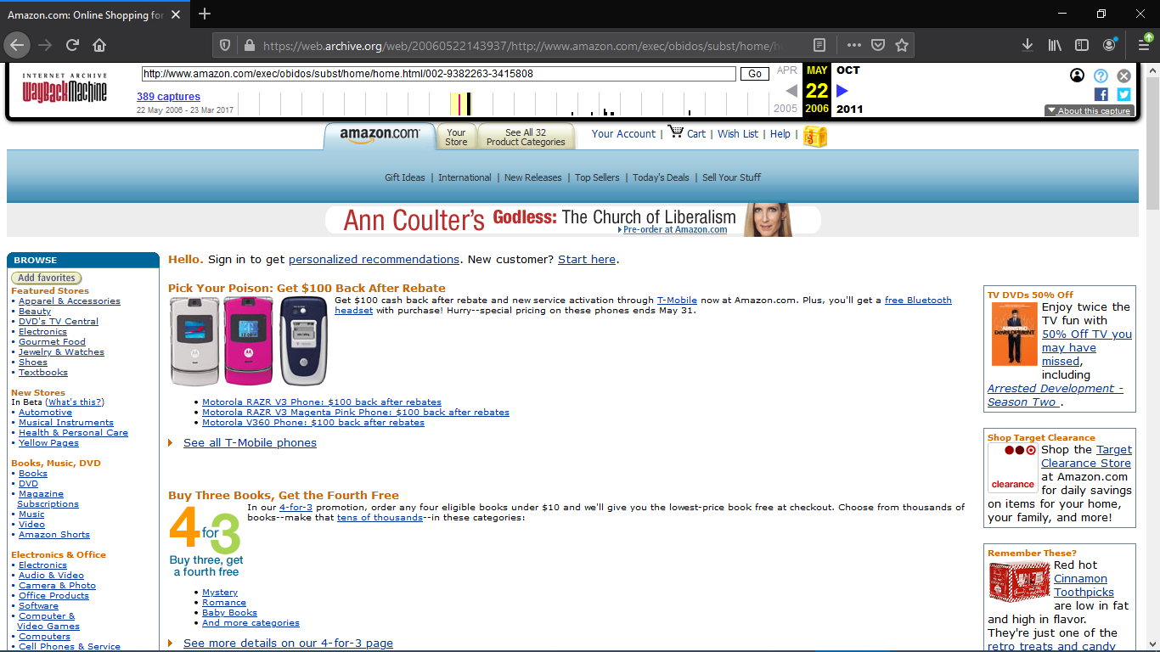

Figure

Snapshot from https://web.archive.org/web/20111018121102/<https://www.amazon.com> on Oct 18 2011.

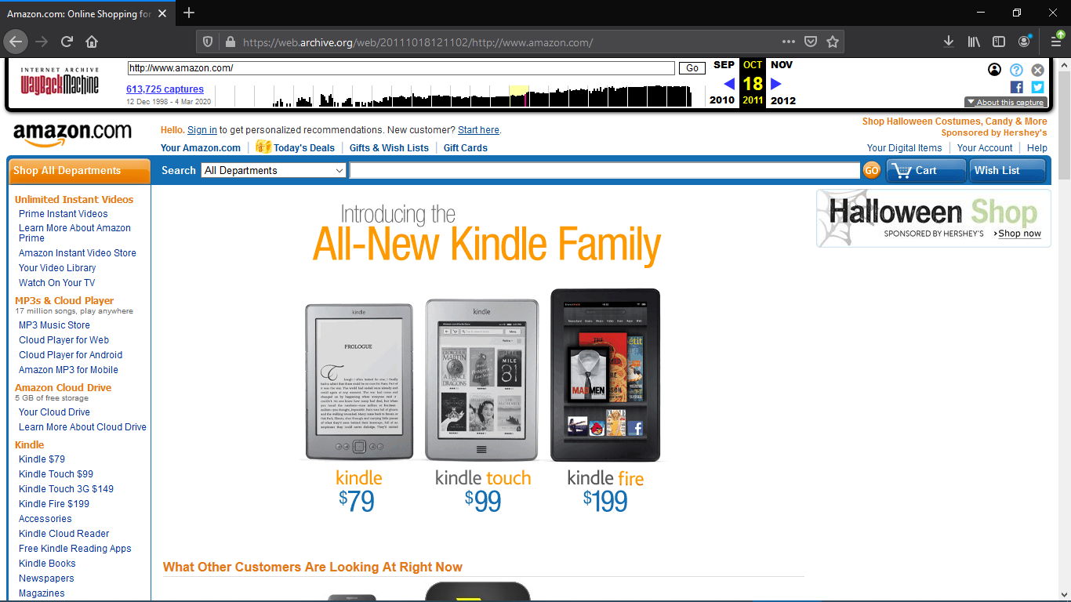

Figure

This is a snapshot from the current amazon.com taken from <https://web.archive.org>

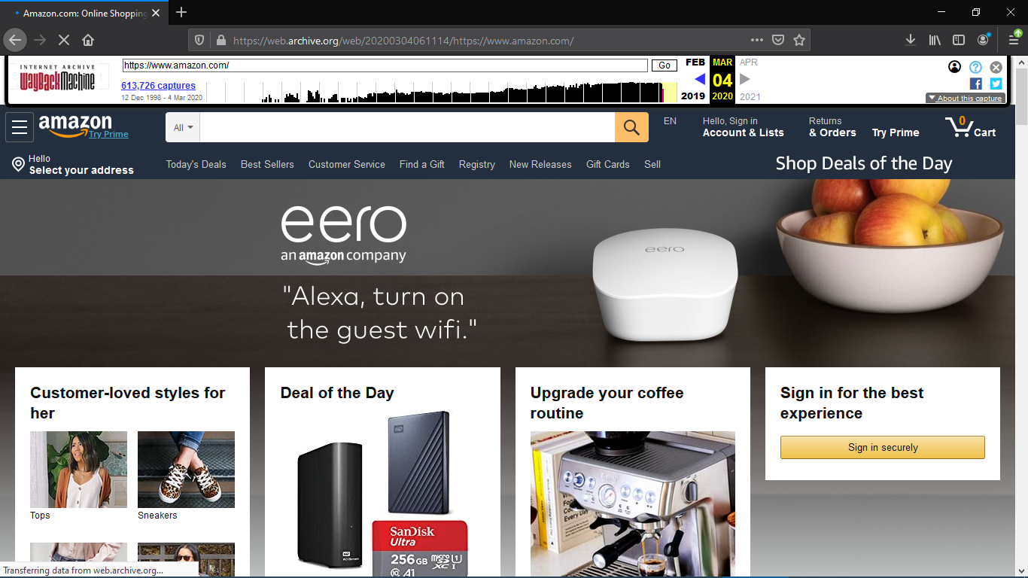

Figure

## **2. Sweetwater**

Sweetwater is probably one of the most versatile and well-known company when it comes to providing quality and professional sound recording equipment, ***Musical Instrument Digital Interface (MIDI)*** devices, and different recording studio gear. They have all types of microphones, studio monitors, production headphones, MIDI keyboards, guitars and a lot more so that you can get a quality recording on your ***Digital Audio Workstation (DAW)*** making it one of the most trusted sites to get the gear you want.

Just like other websites this website has grown over time and below are some images that show what this particular website looked like as the years passed.

Snapshot from https://web.archive.org/web/19990208010504/[https://www.sweetwater.com](https://www.amazon.com) on Feb 08 1999.

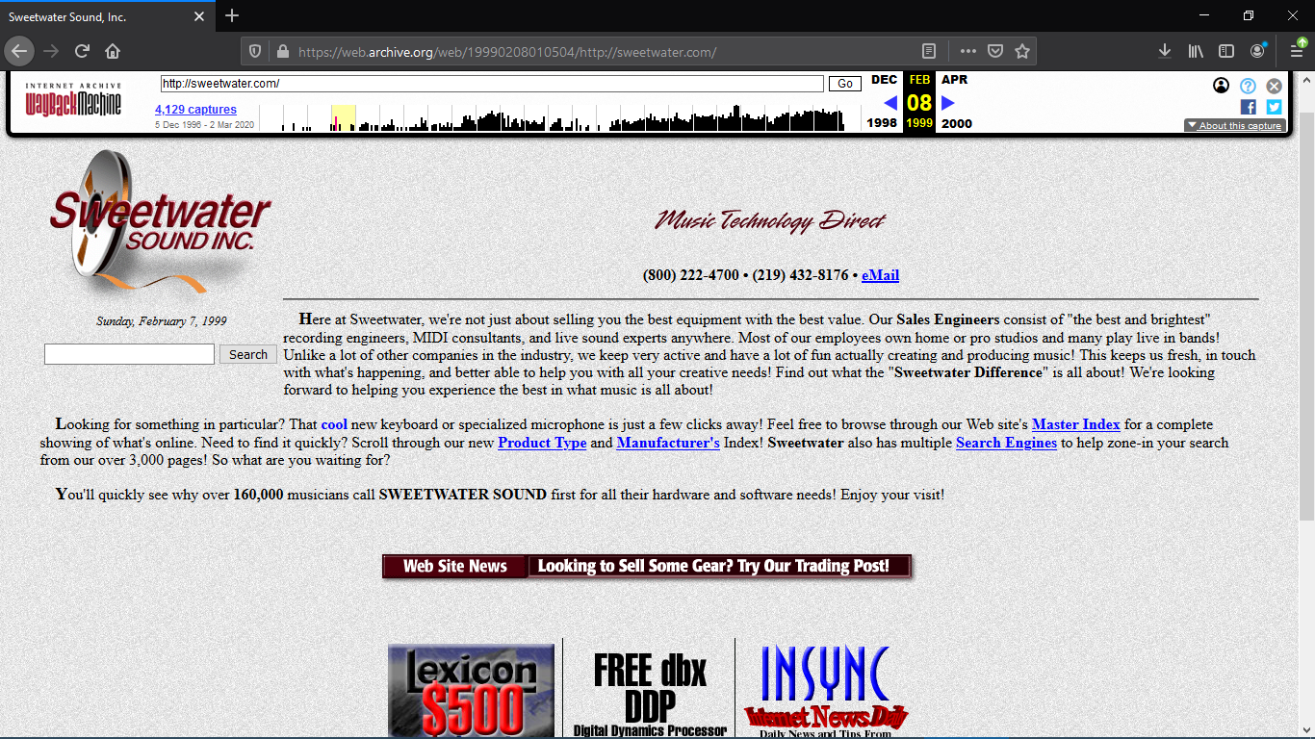

Figure

Snapshot from https://web.archive.org/web/20111113161632/[https://www.sweetwater.com](https://www.amazon.com) on Nov 13 2011.

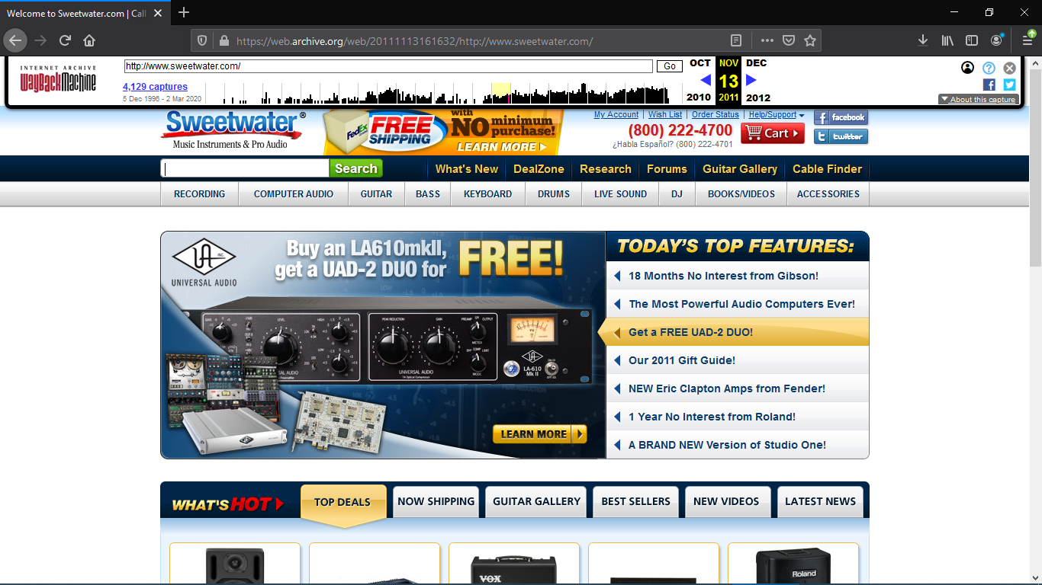

Figure

Snapshot from https://web.archive.org/web/20200302172451/[https://www.sweetwater.com](https://www.amazon.com) on Mar 02 2020.

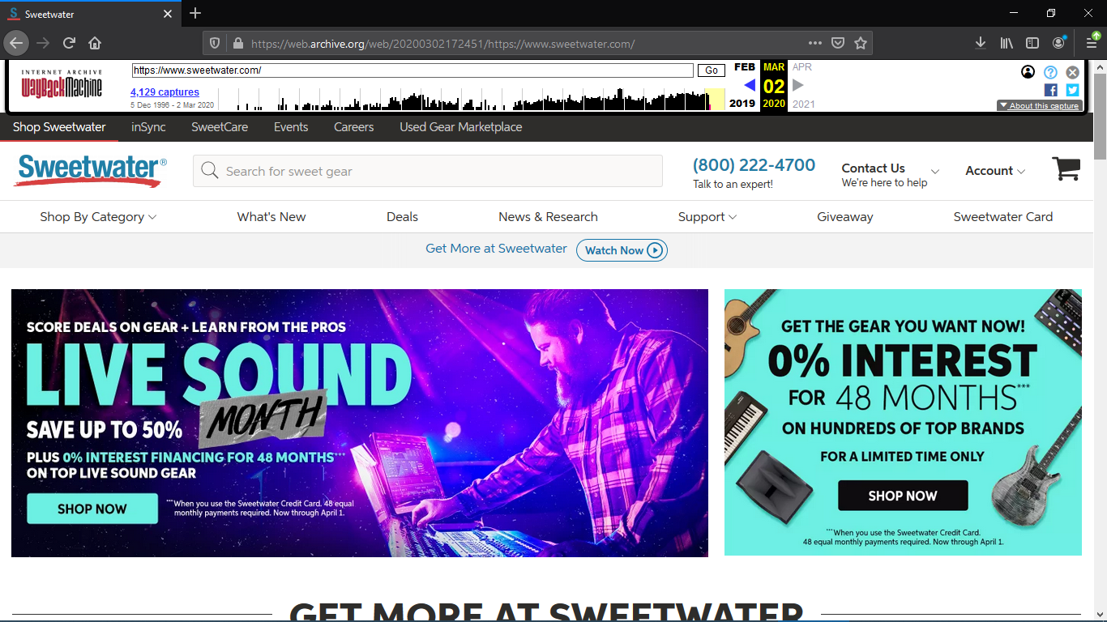

Figure

## **3. YouTube**

This website has been one of the most visited sites, not only because of its appealing appearance but also because it has great content within and is used time and time over by different users, institutes and/or companies for educational purposes. This website is pretty much what everyone would go to in order to get quick answers for their questions.

Snapshot from https://web.archive.org/web/20061109210911/<https://www.youtube.com> on Nov 09 2006.

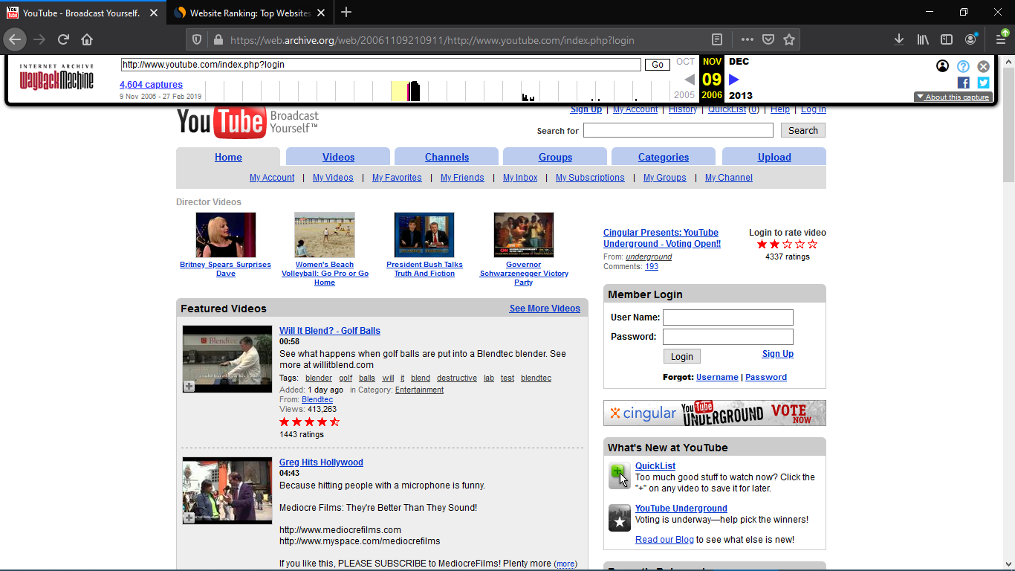

Figure

Snapshot from https://web.archive.org/web/20110614222230/<https://www.youtube.com> on Jun 14 2011.

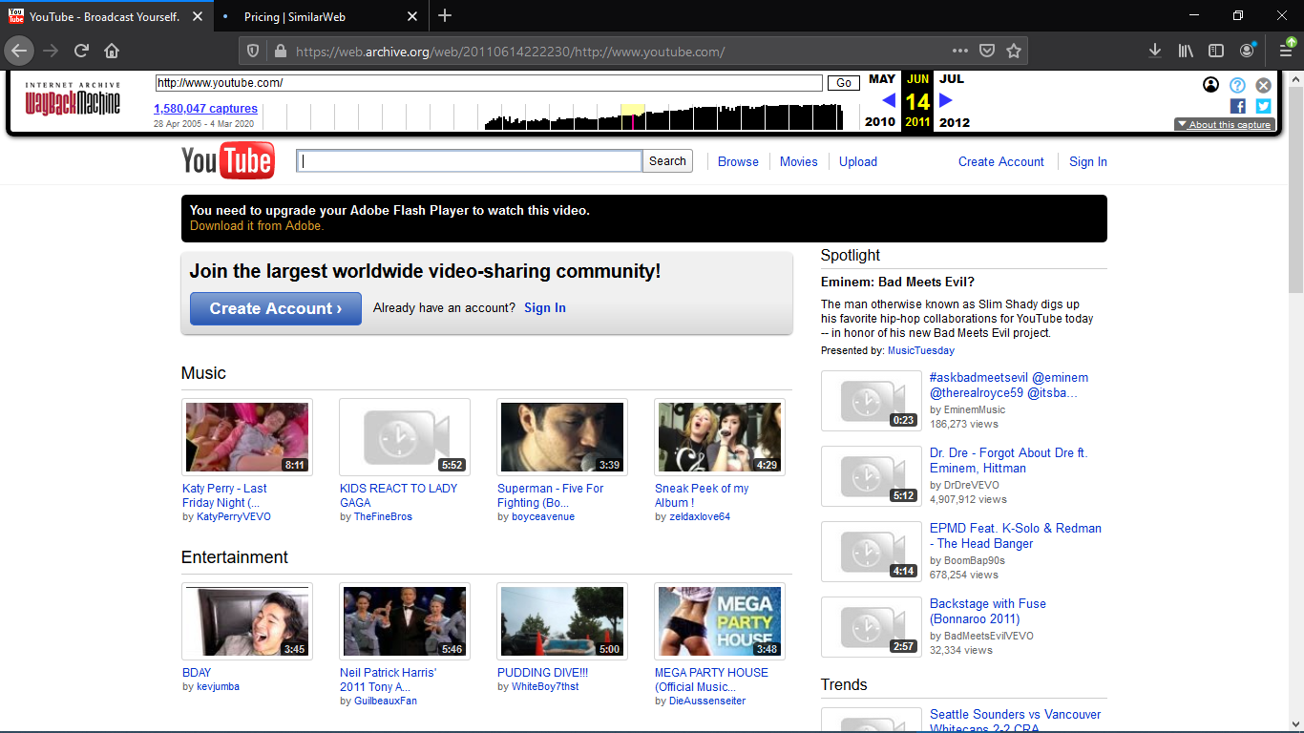

Figure

And this is the current YouTube site that everyone knows.

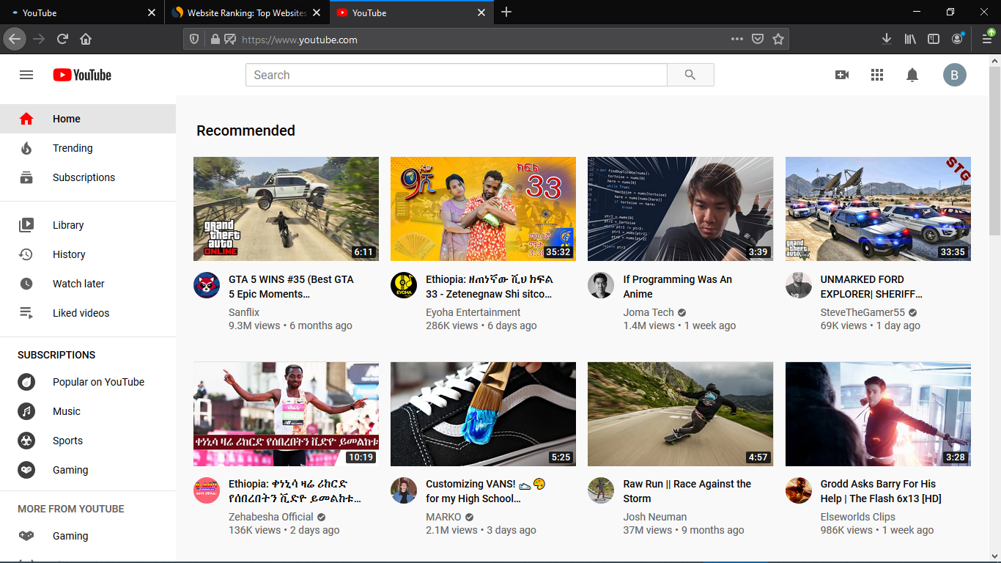

Figure

## **4. Pinterest**

## **5. Wikipedia**

Wikipedia is a free-content online encyclopaedia founded in 2001, collaboratively developed over the World Wide Web in a number of languages.

Snapshot from https://web.archive.org/web/20010727112808/<https://www.wikipedia.org> on Jul 27 2001.

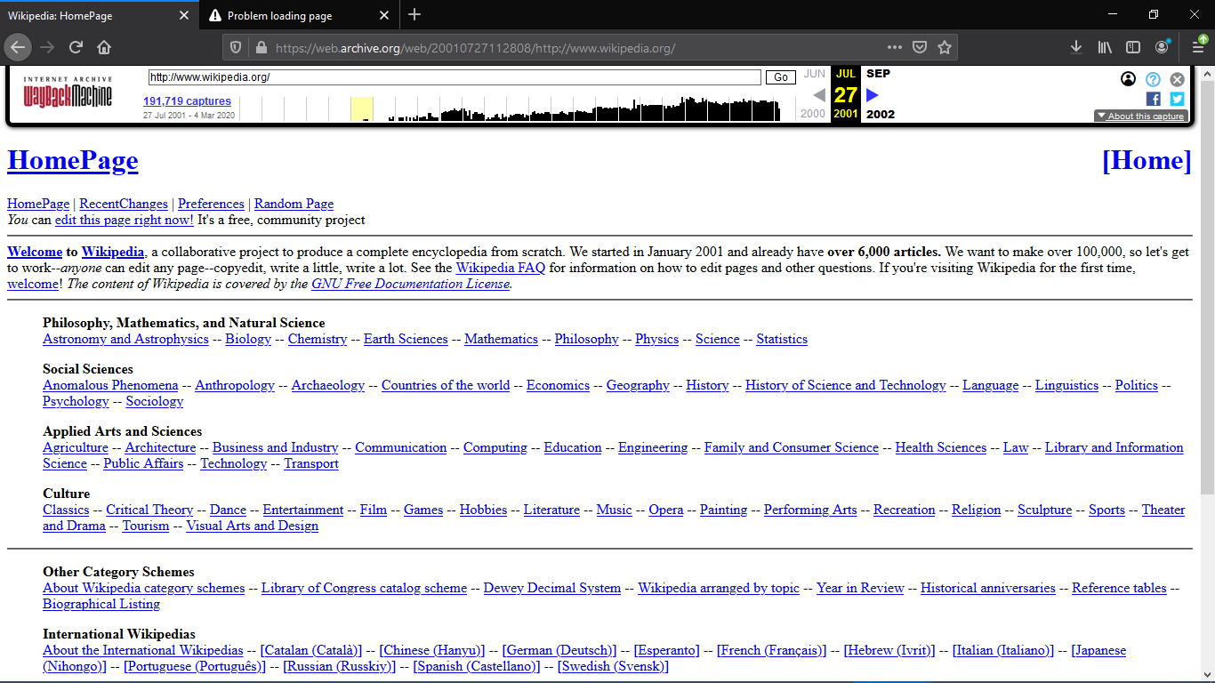

Snapshot from https://web.archive.org/web/20110531205846/<https://www.wikipedia.org> on May 31 2011.

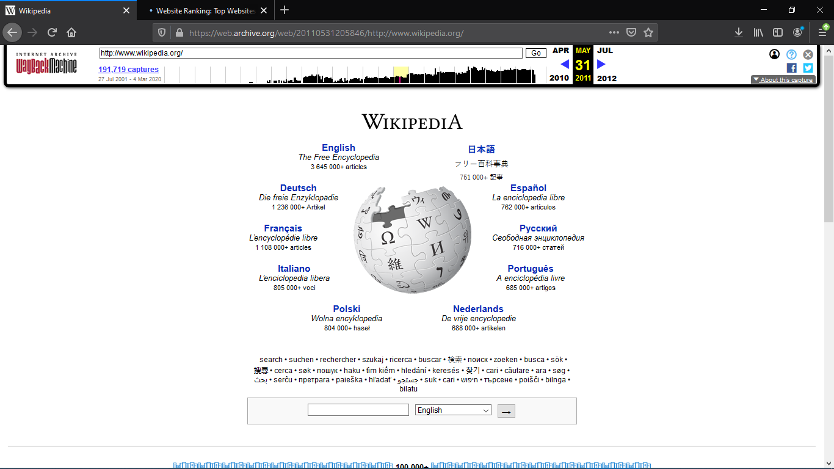

And currently this is what it looks like

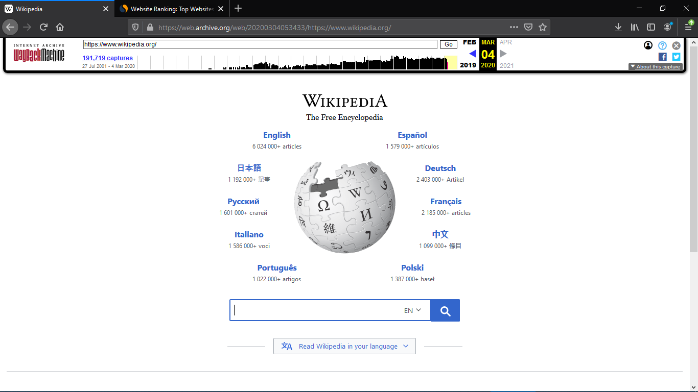

# **Website Categories**

## **Portal**

## **News**

## **Information**

## **Business/Marketing**

## **Educational**

## **Entertainment**

## **Advocacy**

## **Blog**

## **Wiki**

## **Social**

## **Network**

## **Content Aggregator**

## **Personal**

# **Website evaluation guidelines**

There has never been a better time to use the internet and with the increased access to the internet websites are also becoming more and more accessible. So how is it possible to use a website or not visit it at all? The Criterions below might help you understand the value of a website and let you know if that website is worth visiting.

## **Purpose**

* A website should clear a clear and precise in what it wants to show to the user
* It must also reflect its purpose, whether it is to educate, to entertain or even to advertise/sell a product.
* Other advertisements that are not specific over the website shouldn’t overshadow the actual content of the site.

## **Content**

* A sites content should be appropriate and of value to the intended audience, it should have enough information to make visiting the site worthwhile.
* If there is a lot of information within the website, there should be a site map or an outline of topics to allow users to be able to go through the content of the website fluidly.
* The information should be current, accurate and regularly updated so as to keep the targeted audience up to date. A “last updated” notification is a really useful tool.
* Links to more information on a topic, Copyright and licence agreement information should be provided as one can attempt to use part or the whole information found within the website.

## **Authorship/Sponsorship**

* The name of the individual or group that created the website should be clearly stated
* The author or manager of the website should provide true contact information for users to leave comments and ask questions.
* Where applicable, reference sources for information cited should be provided.

## **Technical Considerations**

* Verify that the web site’s important capabilities such as graphics and/or animations critical to the subject matter, can be utilized with the technology you have available. Some sites require more advanced browsers.
* The page should be stable and consistently available. All the links and special features including audio and video must be functioning.
* If there is a fee to use certain features in the site, the website must provide a secure way to make payments.

## **Functionality**

* Languages used in messages and instructions should be clear, concise and easy to interpret.
* There should be consistency in the use of features such as headers, backgrounds, colours and fonts.
* A text-only option is useful for websites that have a lot of graphics, as it takes more time to load the page. Given a fairly good connection speed, time to load a page shouldn’t exceed 15 seconds.

# **Reference:**

* History, <https://www.history.com/news>, Mar 1 2020
* Ericdigest, <https://www.ericdigest.org>, Mar 2 2020